OSI LAYER

Q1. Draw a diagram of the OSI 7-layer model and label each layer with its correct name and a real-world example of a device or protocol that operates at that layer (e.g., Switch at Data Link, HTTP at Application).
Ans.
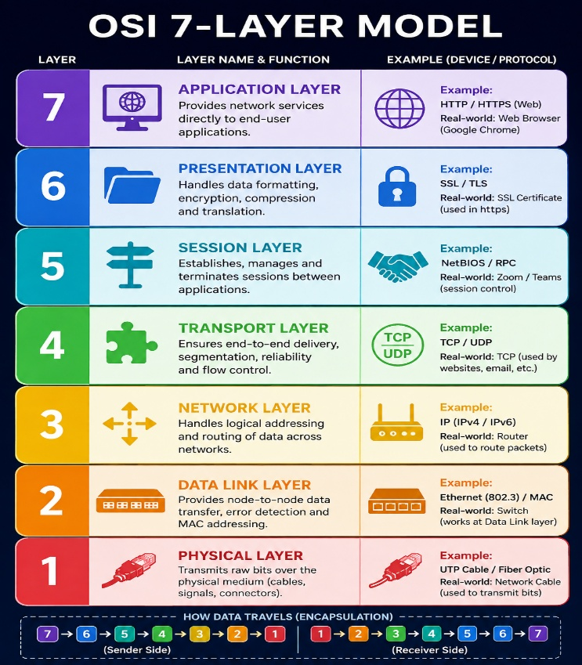

Q2. Match the following networking scenarios to the correct OSI layer: a) Encrypting data before sending, b) Routing packets across networks, c) Converting data to electrical signals, d) Opening a web page in your browser, e) Detecting and correcting errors in frames. Hint: Write your answers as 'Scenario: Layer Name (Layer Number)'.
Ans.
a) Encrypting data before sending: Presentation Layer (Layer 6)
b) Routing packets across networks: Network Layer (Layer 3)
c) Converting data to electrical signals: Physical Layer (Layer 1)
d) Opening a web page in your browser: Application Layer (Layer 7)
e) Detecting and correcting errors in frames: Data Link Layer (Layer 2)

Q3. Pick any app you use daily (like WhatsApp, Instagram, or Zomato) and describe how at least three different OSI layers are involved when you send or receive data in that app.
Ans. Example: WhatsApp
- When I send a message on WhatsApp, different OSI layers work together:
- Application Layer (Layer 7): WhatsApp lets me type and send the message.
- Transport Layer (Layer 4): It helps deliver the message reliably from my phone to the server and then to the receiver.
- Network Layer (Layer 3): It uses IP addresses to route the data through the internet.
- Data Link Layer (Layer 2): Wi-Fi or mobile data sends the data between my phone and the nearby router or network device.
- Physical Layer (Layer 1): The data finally travels as radio waves or electrical/optical signals.

Q4. Given this scenario: You are unable to access a website, but you can successfully ping its IP address. Identify which OSI layer(s) might be causing the problem and explain your reasoning.

Ans. The problem is most likely in the upper OSI layers, because pinging the IP address works.
- Transport Layer (Layer 4): TCP ports like 80 (HTTP) or 443 (HTTPS) may be blocked or not responding.
- Presentation Layer (Layer 6): There could be an SSL/TLS certificate or encryption problem.
- Application Layer (Layer 7): The web server, HTTP/HTTPS service, or browser may have an issue.
Since ping works, the Network Layer (Layer 3) is working correctly and the device can reach the website’s IP address.

